1. 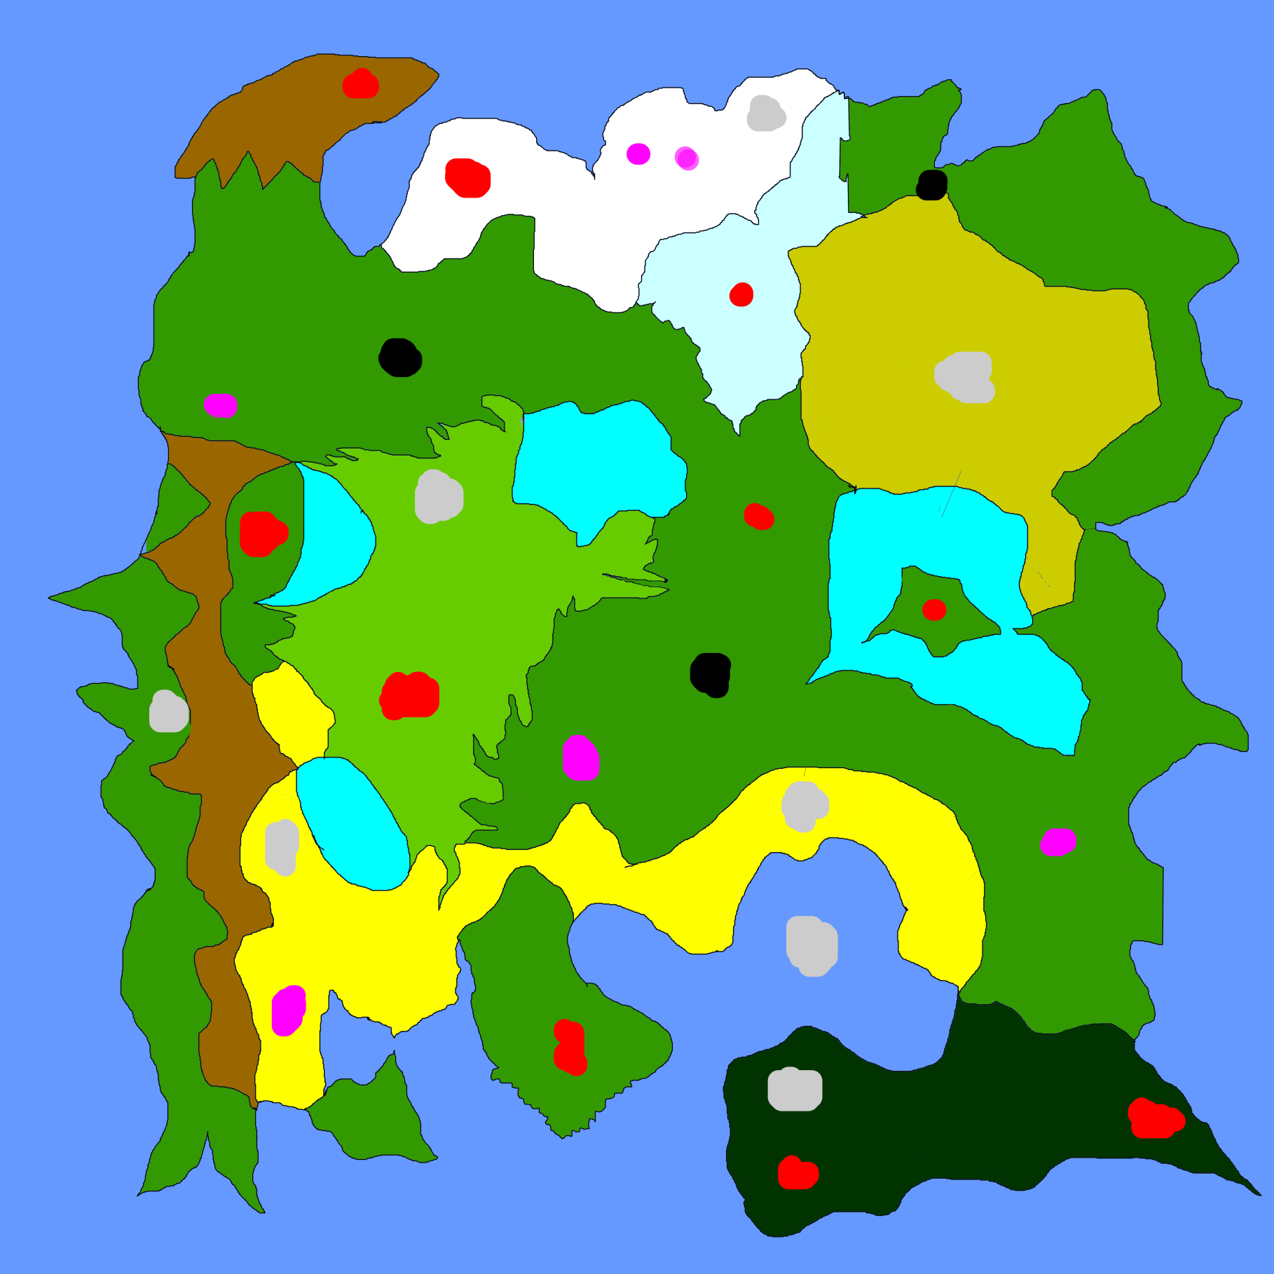Bezerkers=

23

25

27

26

24

22

21

20

19

18

17

16

15

14

13

12

11

10

9

8

7

6

5

4

3

2

1

1. Robotic Morphists=
2. Necromancers=
3. Necropriests=
4. Shadow Morphists=
5. Ghost Town=
6. Illusionists=
7. Destructive Archer=
8. Valhensing= Ransacked town with warped survivors
9. Protection Mages=
10. Elementals=
11. Angelic=
12. Assassins=
13. Robotics=
14. Natural Morphists=
15. Your Hometown=Ransacked but your father lives
16. Rider=
17. Explosives=
18. Demonic=
19. Heavies=Capital City
20. Astral Priests=
21. Hypnopriests=
22. Command=
23. Thieves Lair=
24. Rapid Archers=
25. Lights=
26. Arcane Archers=